IoT Analytics
Wen-Han Hu (whu24)

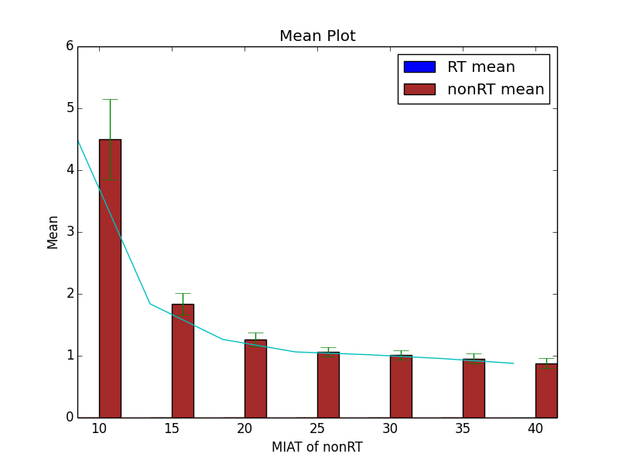
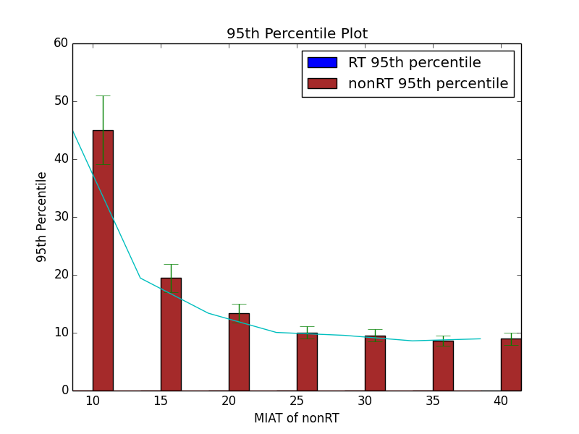

With the results above, we can find that the RT response time always 0 that is because the mean service time of an RT message is much shorter than the mean inter-arrival time of RT messages. The RT message won’t stay in queue, instead, all the RT will be executed right after arrival. In addition, with increment of mean inter-arrival time of nonRT messages, the mean and 95th percentile of nonRT decrease since the queue won’t be too long because the interval increase.

